Lagged cross-correlation: NZDUSD and EURGBP
Method 12 / daily log returns / K_max=10 / Alpari D1 full available history

Study setup
Logical pair: NZDUSD , EURGBP
Broker symbols: NZDUSD_i , EURGBP_i
Snapshot: 2026-11-03_majors_alpari_D1
Timeframe: D1
Matched return window: 1999-01-06 to 2026-11-02 (UTC bar dates)
Matched return count n: 7183
Dropped unfinished last bar dated 2026-11-03 UTC after a tick-volume check against the prior complete day.
Lag definition: rho_X->Y(k) = Corr(x_t, y_{t+k}) on matched D1 bars
K_max = 10; headline lag k = 1 (both directions)
Complete matched rows (Excel): NZDUSD-EURGBP_Lagged_D1.xlsx
Complete matched rows (HTML table): NZDUSD-EURGBP_Lagged_D1_data.html

Method carried forward
Lagged cross-correlation measures Pearson correlation between matched daily log returns of close, ln(close_t / close_t-1), after shifting one series forward by k bars on the matched panel. Quotes are not inverted. rho_{X->Y}(k) = Corr(x_t, y_{t+k}) with n_k = n - k. K_max = 10 is fixed before estimation. The headline is the pre-specified lag k = 1 in both directions. k = 0 is the same-bar side check. The lag inside 1..10 with the largest absolute rho is stored as a descriptive column only; it is not a selected result. This is a linear screen, not proof of forecast edge, economic cause, or a trading signal.

Results (headline k=1)
rho_NZDUSD->EURGBP(1): -0.028542 (n=7182)
95% Fisher interval NZDUSD->EURGBP: [-0.051636, -0.005417]
rho_EURGBP->NZDUSD(1): 0.006758 (n=7182)
95% Fisher interval EURGBP->NZDUSD: [-0.016373, 0.029881]
Same-bar rho(k=0): 0.037186
Largest |rho| among k=1..10 (descriptive only, not selected): NZDUSD->EURGBP k=1 rho=-0.028542; EURGBP->NZDUSD k=6 rho=0.030153

CCF table
k | rho_NZDUSD_to_EURGBP | n_NZDUSD_to_EURGBP | rho_EURGBP_to_NZDUSD | n_EURGBP_to_NZDUSD
0 | 0.03718639 | 7183 | 0.03718639 | 7183
1 | -0.02854178 | 7182 | 0.00675752 | 7182
2 | -0.01230333 | 7181 | 0.00381101 | 7181
3 | 0.00161728 | 7180 | -0.02068255 | 7180
4 | 0.01030215 | 7179 | 0.02102113 | 7179
5 | 0.0131829 | 7178 | 0.01927969 | 7178
6 | -0.011618 | 7177 | 0.03015342 | 7177
7 | -0.00936458 | 7176 | -0.00240346 | 7176
8 | -0.02167887 | 7175 | 0.019458 | 7175
9 | -0.01175223 | 7174 | 0.02587683 | 7174
10 | 0.01213017 | 7173 | 0.02896357 | 7173

Conclusion
At the pre-specified lag k=1 for NZDUSD and EURGBP, rho_{NZDUSD->EURGBP}(1) = -0.0285 (n=7182) and rho_{EURGBP->NZDUSD}(1) = 0.0068 (n=7182). Same-bar rho(k=0) = 0.0372. Largest |rho| among k=1..10 is descriptive only: NZDUSD->EURGBP at k=1 (-0.0285); EURGBP->NZDUSD at k=6 (0.0302). This is a linear screen, not forecast proof or a trading signal.

Charts
Daily closes

Daily log returns

CCF both directions k=0..10
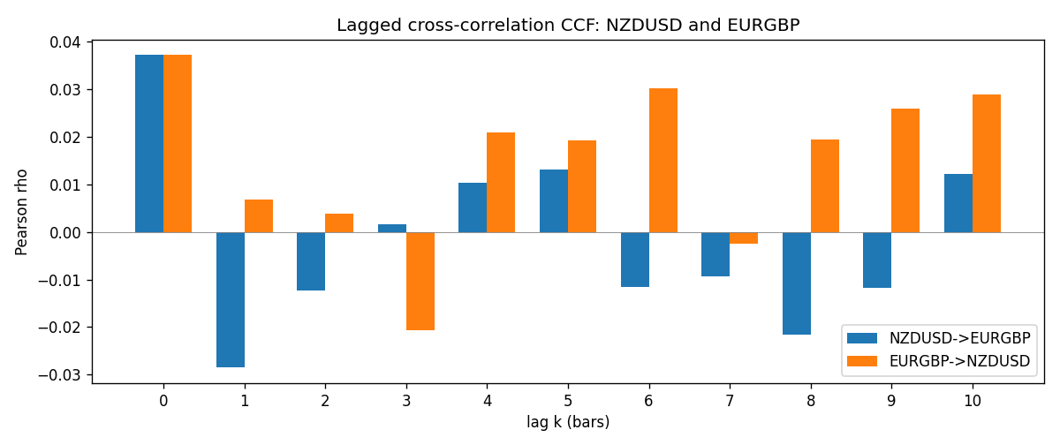

Data report
Every matched row is stored in the sibling Excel workbook named NZDUSD-EURGBP_Lagged_D1.xlsx (sheet matched_rows). The CCF sheet holds rho(k) for k=0..10. Embedding all rows as a Word table is impractical; the Word file holds column summaries and the first and last 15 rows.
Columns: time, NZDUSD_open, EURGBP_open, NZDUSD_high, EURGBP_high, NZDUSD_low, EURGBP_low, NZDUSD_close, EURGBP_close, NZDUSD_tick_volume, EURGBP_tick_volume, NZDUSD_spread, EURGBP_spread, NZDUSD_real_volume, EURGBP_real_volume, NZDUSD_log_return, EURGBP_log_return
Column summaries (matched calculation rows)
column | count | mean | std | min | 25% | 50% | 75% | max
NZDUSD_open | 7183 | 0.65646991 | 0.10818219 | 0.3913 | 0.591455 | 0.6684 | 0.72495 | 0.88218
EURGBP_open | 7183 | 0.78694248 | 0.0966971 | 0.5734 | 0.68755 | 0.83389 | 0.86522 | 0.9769
NZDUSD_high | 7183 | 0.66038812 | 0.10867344 | 0.3961 | 0.5949 | 0.67204 | 0.729365 | 0.88421
EURGBP_high | 7183 | 0.7900202 | 0.09707133 | 0.5789 | 0.6896 | 0.8369 | 0.8681 | 0.9799
NZDUSD_low | 7183 | 0.65278196 | 0.10777661 | 0.3897 | 0.58816 | 0.6642 | 0.720985 | 0.87988
EURGBP_low | 7183 | 0.78424251 | 0.0965143 | 0.5682 | 0.6855 | 0.83166 | 0.86287 | 0.9661
NZDUSD_close | 7183 | 0.65654354 | 0.10817679 | 0.3907 | 0.59181 | 0.6685 | 0.72502 | 0.8822
EURGBP_close | 7183 | 0.78698724 | 0.09669475 | 0.5735 | 0.68775 | 0.83395 | 0.86536 | 0.977
NZDUSD_tick_volume | 7183 | 68736.568 | 123152.54 | 16 | 5594.5 | 33901 | 58513.5 | 1127682
EURGBP_tick_volume | 7183 | 87133.158 | 145499.84 | 154 | 6553 | 44358 | 81413 | 1424684
NZDUSD_spread | 7183 | 30.260755 | 25.633067 | 0 | 9 | 17 | 40 | 80
EURGBP_spread | 7183 | 21.328832 | 19.122264 | 0 | 4 | 13 | 40 | 50
NZDUSD_real_volume | 7183 | 1.6708354e+10 | 8.49951e+10 | 0 | 0 | 0 | 0 | 2.705649e+12
EURGBP_real_volume | 7183 | 2.7872287e+10 | 1.3521454e+11 | 0 | 0 | 0 | 0 | 3.5726265e+12
NZDUSD_log_return | 7183 | 1.073e-05 | 0.0076464 | -0.07027433 | -0.00425909 | 0.00022967 | 0.00458236 | 0.05966839
EURGBP_log_return | 7183 | 2.33e-05 | 0.00487088 | -0.03067367 | -0.00262163 | -9.879e-05 | 0.002558 | 0.06075387
First 15 matched rows (selected columns)
time | NZDUSD_close | EURGBP_close | NZDUSD_log_return | EURGBP_log_return
1999-01-06 | 0.5383 | 0.7019 | 0.0020455609 | -0.013303338
1999-01-07 | 0.5417 | 0.7097 | 0.0062963171 | 0.011051402
1999-01-08 | 0.5414 | 0.7062 | -0.00055396548 | -0.004943862
1999-01-11 | 0.547 | 0.7053 | 0.010290425 | -0.0012752393
1999-01-12 | 0.5441 | 0.7077 | -0.0053157489 | 0.0033970309
1999-01-13 | 0.5387 | 0.708 | -0.0099742238 | 0.00042381861
1999-01-14 | 0.5386 | 0.7066 | -0.00018564931 | -0.0019793588
1999-01-15 | 0.5382 | 0.7012 | -0.00074294208 | -0.0076715819
1999-01-18 | 0.5372 | 0.7017 | -0.0018597736 | 0.00071280921
1999-01-19 | 0.5382 | 0.7007 | 0.0018597736 | -0.0014261269
1999-01-20 | 0.5404 | 0.7021 | 0.0040793678 | 0.0019960086
1999-01-21 | 0.5426 | 0.7016 | 0.0040627941 | -0.00071240297
1999-01-22 | 0.5361 | 0.7004 | -0.012051689 | -0.0017118406
1999-01-25 | 0.5342 | 0.6966 | -0.0035504102 | -0.0054402425
1999-01-26 | 0.5381 | 0.6962 | 0.0072741158 | -0.00057438255
Last 15 matched rows (selected columns)
time | NZDUSD_close | EURGBP_close | NZDUSD_log_return | EURGBP_log_return
2026-10-13 | 0.56127 | 0.84458 | 0.0047326165 | 0.00020130374
2026-10-14 | 0.55918 | 0.84553 | -0.0037306483 | 0.0011241873
2026-10-15 | 0.56185 | 0.84479 | 0.0047634855 | -0.00087557391
2026-10-16 | 0.56509 | 0.84307 | 0.0057501001 | -0.0020380844
2026-10-19 | 0.56616 | 0.84259 | 0.0018917133 | -0.00056950988
2026-10-20 | 0.56827 | 0.83957 | 0.0037199341 | -0.0035906254
2026-10-21 | 0.57003 | 0.83839 | 0.0030923331 | -0.00140647
2026-10-22 | 0.56815 | 0.83682 | -0.0033035227 | -0.0018743924
2026-10-23 | 0.56991 | 0.83751 | 0.0030929853 | 0.00082421033
2026-10-26 | 0.56826 | 0.83762 | -0.0028993932 | 0.00013133309
2026-10-27 | 0.56811 | 0.83595 | -0.00026399852 | -0.0019957343
2026-10-28 | 0.56261 | 0.83651 | -0.0097283914 | 0.00066967224
2026-10-29 | 0.56296 | 0.83553 | 0.00062190714 | -0.0011722209
2026-10-30 | 0.56307 | 0.83351 | 0.00019537668 | -0.0024205543
2026-11-02 | 0.56161 | 0.83426 | -0.0025962955 | 0.00089940465

